CKA 2025 Isn’t Harder — Here’s My 3-Attempt Story to Prove It



K Sai Harsha
Follow
6 min read
·
Sep 14, 2025
27

When I hit the “submit” button at the end of my CKA 2025 exam, I sat back with my heart pounding. The myths had been swirling for months: “It’s much harder now.” “You’ll never finish in time.” “Helm and CRDs will eat you alive.”
But, when I finally saw the word “Pass” on my CKA 2025 results, I froze. This wasn’t my first attempt — or my second. It was my third try.
By then, I had already wrestled with doubts: “Maybe Kubernetes isn’t for me.” “Maybe the exam really did get impossibly hard.” But in that moment, all the myths, the late-night practices, and the disappointments melted away. I wasn’t just certified — I felt like I had launched into a new orbit. I had become, in the truest sense, a Kubestronaut.
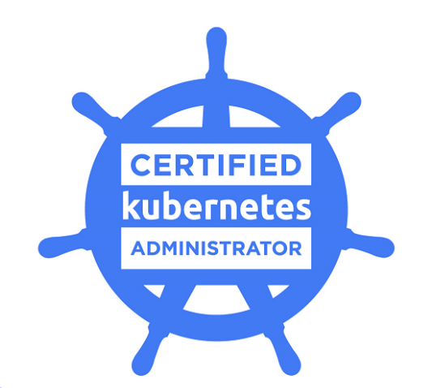
What People Are Saying vs What I Found (The Myths)
There are a lot of “CKA is so much harder now” threads out there. After the Feb 18, 2025 changes, yes, new topics were added: Helm, Kustomize, CRDs (Custom Resource Definitions). Also, there’s more emphasis now on troubleshooting and comprehension vs just speed.
Here’s what I actually found:
Belief / Myth
“They expect you to know EVERYTHING in minute detail.”
My Reality
They expect you to understand and apply. The exam will test you on core concepts + ability to combine them under time pressure, not memorization of every flag or plugin.
Belief / Myth
“New topics make the exam impossible if you haven’t seen them before.”
My Reality
True they are new, but well-covered by good courses, mock exams, documentation. With proper preparation (especially for Helm, Kustomize, CRDs), these became manageable.
What Was Different in CKA 2025 (After Feb Changes)
Here are the main changes I noticed (and confirmed others noticed) that people prepping need to take into account:
- New topics: Helm, Kustomize, CRDs are now in the syllabus.
- More weight on troubleshooting: Problems combining multiple components are common.
- Exam format: More questions that require you to SSH into different nodes, set up contexts, perhaps multiple clusters. Documentation usage is still open-book (allowed docs), but you must be fast and know where to find info.
- Interface quirks and usability issues: Some examinees report that the exam UI is less forgiving than mock labs — scrolling, zooms, small terminal panes, sometimes freezing. These UI “surprises” can cost time.
Attempt #1 — When Tech Fails You
My first attempt ended in frustration — not because of Kubernetes, but because of the PSI monitoring browser streaming issues. The exam crashed midway, and I couldn’t complete it. It felt crushing to lose hours of preparation that way.
But here’s where CNCF impressed me: after I explained the situation, they granted me a free retake. That small gesture kept my motivation alive.
Attempt #2 — The Overconfidence Trap
The second time, I went in too confident. I thought I knew the exam flow inside out. But the CKA is not just about commands — it’s about time management, prioritization, and focus under pressure. I got stuck on a few questions, lost track of time, and walked out with a near miss.



Failure stung, but it also grounded me. I realized that passing this exam is not just about Kubernetes knowledge, but about discipline in execution.
Attempt #3 — Finally Launching into Orbit
By the third attempt, I had adjusted my mindset.
- I practised realistic mock exams with strict timers.
- I refined my kubectl shortcuts, bookmarks, and YAML speed.
- I focused on core domains (troubleshooting, networking, RBAC, etc.) instead of spreading too thin.
This time, I stayed calm, paced myself, and finally — I passed.
Press enter or click to view image in full size
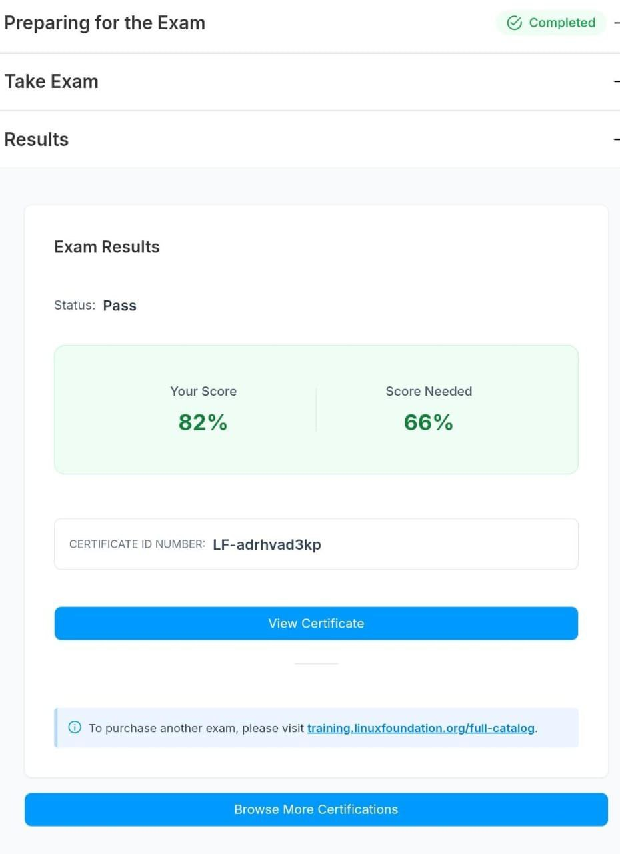
My score in 3rd attempt :)
My Preparation: What Worked
Here are my strategies, in what order and how I used them. Use this as a template:
- Understand the Updated Syllabus Early
I went through the Linux Foundation’s objectives thoroughly after the Feb 2025 update. I made a checklist: which topics I’d never used or felt weak in (Helm, CRDs, etc.) — training.linuxfoundation.org/certified-kubernetes-administrator-cka-program-changes/
- Hands-On Practice Every Day
— Spun up clusters locally (using kind / kubeadm / maybe cloud credits) and practised things end-to-end (installation → upgrades → RBAC → network policies → custom resources).
— Did labs from killercoda and scenario challenges in kodekloud/ killer.sh mock exams are non-negotiable.
- Simulators & Mock Exams Under Time Pressure
I used both exam simulators provided by the Linux Foundation + external ones. I practiced finishing in less than the full allotted time, so that I had buffer to revisit flagged items.
- Documentation Familiarity
Since you are allowed to use official Kubernetes docs, I practised using them: finding things fast, searching, toggling versions, YAML examples. Knowing the layout helped — kubernetes.io
- Mindset and Strategy
- If stuck, flag and move on.
- Keep track of time per question so you don’t spend too long on one.
- Don’t try to perfect everything; getting partial credit is better than deadlock.
- Keep calm: exam interface issues / network lags etc can happen — plan for them (e.g. using wired connection, good machine, quiet place).
What I Saw in the Exam: Real Tasks & Questions (Generalized)
Here are some representative tasks I faced, and what made them non-trivial. I won’t give exact questions, but things that can help you mentally prepare:
- ### Integrate Application Logs with Sidecar Container
Enhance the existing deployment by attaching a helper container that streams the main application’s log file using a shared volume, ensuring compatibility with Kubernetes logging tools.
- ### Create and Configure Custom StorageClass
Define a new storage class optimized for low latency, assign it as the default, and ensure it only binds volumes when a pod is present, without changing ongoing workloads.
- ### Autoscale Application with HPA
Implement an autoscaler for a deployment to maintain a steady CPU usage at 50%, limiting the number of replicas between one and four and tuning stabilization settings for scaling down.
- ### Transition to Gateway API for Web Service
Replace legacy ingress rules with a new gateway setup, maintaining secure access and replicating existing routes and TLS settings, then remove outdated resources.
- ### Restrict NGINX Deployment to Modern TLS
Reconfigure an NGINX instance to accept only the latest TLS connections by updating its config map, preventing older protocols from establishing connections.
- ### ArgoCD Helm Chart Installation without CRDs
Generate a Helm chart template for ArgoCD and install it using specific settings to avoid unnecessary resource installation, streamlining ArgoCD setup.
- ### Enforce High Pod Scheduling Priority
Establish a high-priority class for pods and update a targeted deployment to utilize this priority, ensuring critical workloads are favoured during resource contention.
- ### Update Service Exposure for Deployment
Modify an application’s deployment to open a specific network port and create a dedicated service that grants both cluster-internal and node-based external access.
- ### Prepare Host for Kubernetes Installation
Install a container runtime and adjust key operating system network parameters to support Kubernetes requirements, ensuring these settings persist after restarts.
- ### Route HTTP Traffic with Ingress Resource
Set up a new ingress resource that directs traffic to a specific backend service and port, enabling public HTTP reachability for the application endpoint.
- ### Apply Strict Security Controls to Namespace
Implement the Kubernetes restricted pod security standard in the specified namespace to ensure that all pods are blocked from gaining privileged mode, accessing host-level networking, or receiving any permissions above the minimum required.
These reflect the kind of deeper understanding + combining of topics expected in CKA 2025.
Time & Exam Day Reality: What You Should Know
- You get 2 hours (120 minutes) for all tasks. Time flies.
- The exam environment is remote, proctored. Some people had issues with UI freezing, small terminal windows, or weird scroll behavior. If possible, use a machine you are comfortable with and test the PSI or whatever proctor tool beforehand.
- Internet stability is crucial. Use wired, backup connection if possible.
- Read each question carefully; sometimes details (namespace, context, node) matter. Missing a subtle flag can cause a task to fail.
- At the end, if time remains, revisit flagged tasks. Don’t leave them hanging.
Final Thoughts
My third attempt wasn’t just about passing an exam — it was about proving to myself that persistence beats panic.
So if you’re on this journey, keep training, keep practising, and don’t let myths hold you back. Because one day, you too will look at that screen, see “Pass,” and feel like you’ve launched into orbit.
If I could do it, then you can do it too. :)
Welcome, future Kubestronauts. 🚀

